EXP – 8 STATIC ROUTING

Name: L.Ishitha
Roll Number: 2420030041
Sec – 5
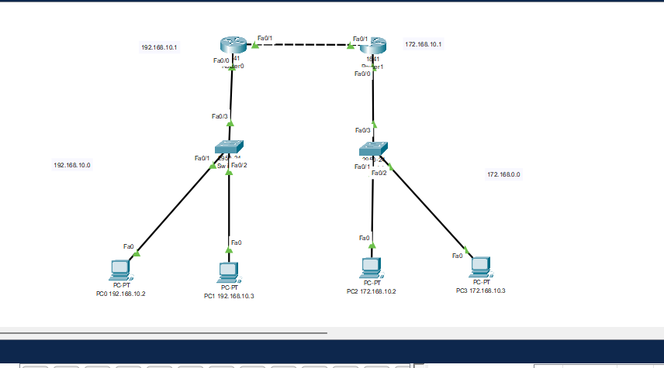

Static Routing Commands

1. Enter Global Configuration Mode
Command: configure terminal
This command is used to enter the global configuration mode on a Cisco router.

2. Enter IP Routing Mode
Command: ip routing
This enables the IP routing process on the router.

3. Configure Static Route
Command: ip route <destination-network> <subnet-mask> <next-hop-IP>
This is the main command to define a static route.
Example: ip route 192.168.2.0 255.255.255.0 192.168.1.2

4. Verify Static Route Configuration
Command: show ip route
This command displays the routing table of the router and allows you to verify the static routes.

5. Save Configuration
Command: write memory or copy running-config startup-config
This saves the static routing configuration so that it persists after a reboot.

